**Amy Wang**

**MSCI 240 Fall 2018**

**Instructor: Dr Mark Hancock**

**October 24th, 2018**

**Homework 4**

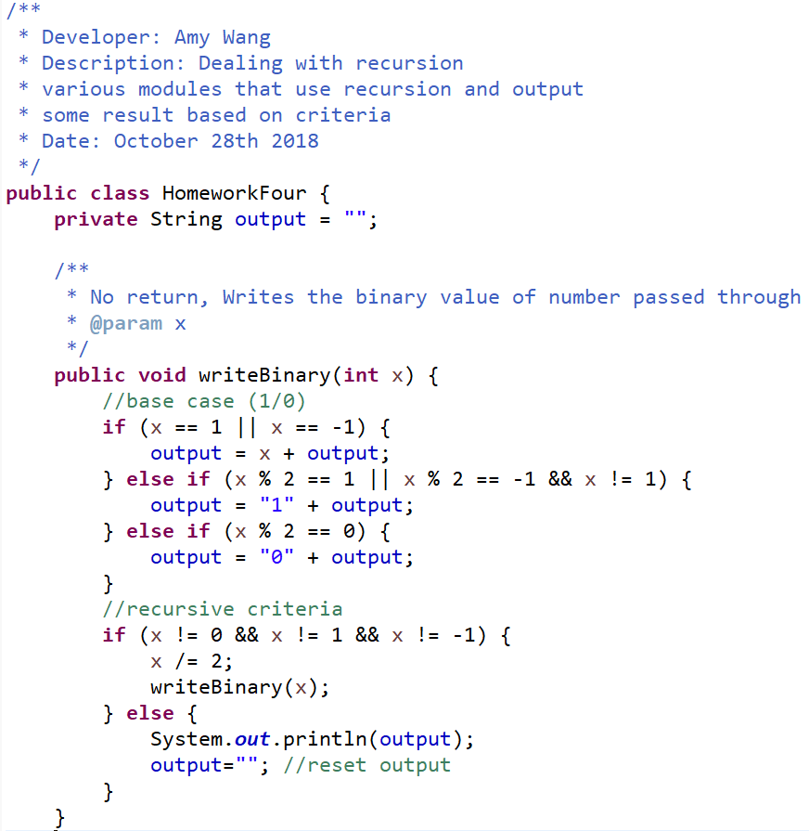

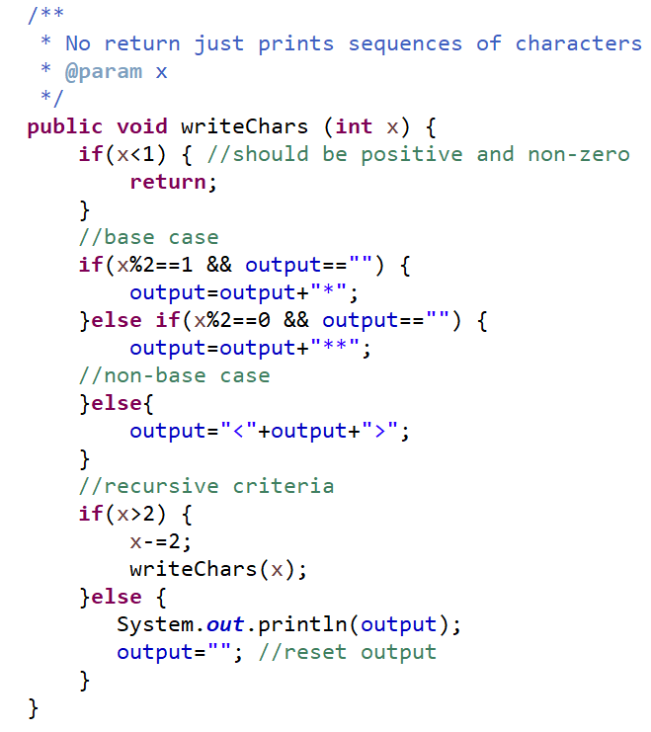

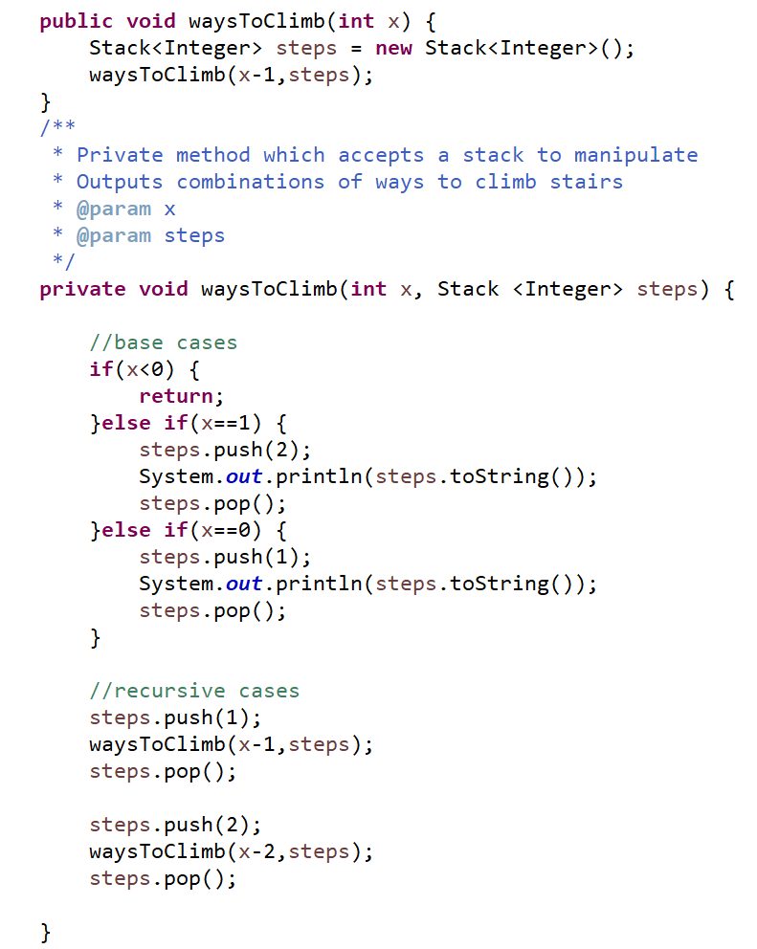

# Non-Acknowledgment of Receiving Assistance or Use of Others' Ideas

I received the following help, assistance, or any ideas from classmates, other knowledgeable people, books or non-course websites (please include a description of discussions with the TA or the instructor):

None

# Record of Giving Assistance to Others

I gave the following help, assistance, or ideas to the following classmates (please describe what assistance to whom was given by you):

None

# Declaration

I declare that except for the assistance noted above, assistance provided on the course website, and material provided by the instructor and/or TAs that this is my original work.

I have neither given nor received an electronic or printed version of any part of this code to/from anyone.

I declare that any program output submitted as part of the assignment was generated by the program code submitted and not altered in any way.

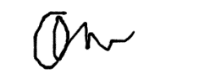

Signature: _______________________________